

**National Universityof Computer and Emerging sciences**

**OBJECTIVES:**

* To learn and understand how to design a multiple output combinational circuit
* To learn and understand the working of 2-bit binary comparator
* Adder/Subtractor

**APPARATUS:**Logic trainer, Logic probe

**COMPONENTS:**ICs 74LS08, 74LS32, 74LS04, 74LS86, 74LS02

**THEORY:**

Binarycomparator is a combinational circuit that compares magnitude of two binary data signals A & Band generates the results of comparison in the form of three outputsignals A>B, A=B, A<B.

**One-bit comparator:**

One-bit comparator compares magnitude of two numbers A and B, 1 bit each, and generates the comparison result. The result consists of three outputs let us say L, E, G, so that

$$L=1 if A<B$$

$$E=1 if A=B$$

$$G=1 if A>B$$

**Truth Table:**

|  |  |  |  |  |
| --- | --- | --- | --- | --- |
| **Inputs** | | **Outputs** | | |
| **A** | **B** | **L** | **E** | **G** |
| 0 | 0 | 0 | 1 | 0 |
| 0 | 1 | 1 | 0 | 0 |
| 1 | 0 | 0 | 0 | 1 |
| 1 | 1 | 0 | 1 | 0 |

**K-Maps for Outputs:**

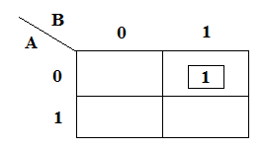 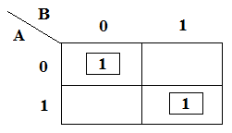 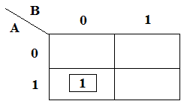

K-Map for Output **L**K-Map for Output **E**K-Map for Output **G**

**Boolean Expressions of Outputs:**

**L: $\overline{A}B______$**

**E: $AB+ \overline{A}\overline{B}_$**

**G: $A\overline{B}______$**

**Exclusive-OR & Exclusive-NOR gates:**

The figure given below shows the symbol of Exclusive-OR (XOR) and Exclusive-NOR (XNOR) gates.

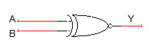

XNOR gate XOR gate

Boolean expression of XNOR gate is $AB+ \overline{A}\overline{B}$ and Boolean expression of XOR is $\overline{A}B+A\overline{B}$. Boolean expression of XNOR gate can be implemented using XOR gate as shown in figure below:



**Circuit Diagram for one-bit comparator:**

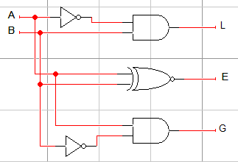

In this experiment 74LS86 IC will be used for implementation of XOR gate function. 74LS86 IC contains four 2-input XOR gates. The function table and connection diagram for this IC are shown below:

**Function Table:**

|  |  |  |
| --- | --- | --- |
| **Inputs** | | **Output** |
| **A** | **B** | **Y** |
| L | L | L |
| L | H | H |
| H | L | H |
| H | H | L |

H= Logic High, L= Logic Low

**Connection Diagram:**

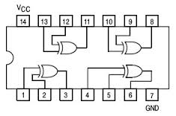

**Adder and subtractor**

**Half Adder:**

Half adder is a logic circuit that performs binary addition of two 1-bit numbers. It generates two outputs namely ‘**Sum**’ and ‘**Carry**’.

**Truth Table:**

|  |  |  |  |
| --- | --- | --- | --- |
| **A** | **B** | **Carry** | **Sum** |
| 0 | 0 | 0 | 0 |
| 0 | 1 | 0 | 1 |
| 1 | 0 | 0 | 1 |
| 1 | 1 | 1 | 0 |

**Boolean Expressions of Outputs:**

$Sum=A⊕B$

$Carry=AB$

**Half Subtractor:**

Half subtractor is a logic circuit that performs binary subtraction of two 1-bit numbers. It generates two outputs namely ‘**Difference**’ and ‘**Borrow**’.

**Truth Table:**

|  |  |  |  |
| --- | --- | --- | --- |
| **A** | **B** | **Borrow** | **Difference** |
| 0 | 0 | 0 | 0 |
| 0 | 1 | 1 | 1 |
| 1 | 0 | 0 | 1 |
| 1 | 1 | 0 | 0 |

**Boolean Expressions of Outputs:**

$Difference=A⊕B$

$Borrow= \overline{A}B$

**Full Adder:**

Full adder is a logic circuit that performs binary addition of two 2-bit numbers. It generates two outputs namely ‘**Sum**’ and ‘**Carry**’.

**Truth Table:**

|  |  |  |  |  |
| --- | --- | --- | --- | --- |
| **A** | **B** | **C** | **Carry** | **Sum** |
| 0 | 0 | 0 | 0 | 0 |
| 0 | 0 | 1 | 0 | 1 |
| 0 | 1 | 0 | 0 | 1 |
| 0 | 1 | 1 | 1 | 0 |
| 1 | 0 | 0 | 0 | 1 |
| 1 | 0 | 1 | 1 | 0 |
| 1 | 1 | 0 | 1 | 0 |
| 1 | 1 | 1 | 1 | 1 |

**Boolean Expressions of Outputs:**

$Sum=A⊕B⊕C$

$Carry= AB+BC+AC$ or $Carry= AB+C(A⊕B)$

**Full Subtractor:**

Full subtractor is a logic circuit that performs binary subtraction of two 2-bit numbers. It generates two outputs namely ‘**Difference**’ and ‘**Borrow**’.

**Truth Table:**

|  |  |  |  |  |
| --- | --- | --- | --- | --- |
| **A** | **B** | **C** | **Borrow** | **Difference** |
| 0 | 0 | 0 | 0 | 0 |
| 0 | 0 | 1 | 1 | 1 |
| 0 | 1 | 0 | 1 | 1 |
| 0 | 1 | 1 | 1 | 0 |
| 1 | 0 | 0 | 0 | 1 |
| 1 | 0 | 1 | 0 | 0 |
| 1 | 1 | 0 | 0 | 0 |
| 1 | 1 | 1 | 1 | 1 |

**Boolean Expressions of Outputs:**

$Difference=A⊕B⊕C$

$Borrow= \overline{A}B+BC+\overline{A}C$ or $Carry= \overline{A}B+C(\overline{A}⊕B)$

**Lab Task 1:**

Design a combinational circuit and implement on logic works that compares two 2-bit numbers and generates the comparison result. The result consists of three outputs let us say L, E, G, so that

$$L=1 if A<B$$

$$E=1 if A=B$$

$$G=1 if A>B$$

1. Write truth table
2. Find minimal SOP expressions for the outputs **L**, **E**, and **G** using K-map. Draw separate K-map for each output in the space given below.

**Lab Task 2:**

Implement full adder and full subtractor on logic trainer.

**Lab Task 3:**

Implement 4-bit even parity detectoron logic trainer